Lab Experiments

1.Python Pandas Program: Select Distinct Department IDs
Code:
import pandas as pd
# Create DataFrame directly
df = pd.DataFrame({
"DEPARTMENT_ID": [10,20,30,40,50,60,70,80,90,100,110,120,130,140,150,160,170,180,190,200,210,220,230,240,250,260,270],
"DEPARTMENT_NAME": [
"Administration","Marketing","Purchasing","Human Resources","Shipping",
"IT","Public Relations","Sales","Executive","Finance","Accounting",
"Treasury","Corporate Tax","Control And Credit","Shareholder Services",
"Benefits","Manufacturing","Construction","Contracting","Operations",
"IT Support","NOC","IT Helpdesk","Government Sales","Retail Sales",
"Recruiting","Payroll"
],
"MANAGER_ID": [200,201,114,203,121,103,204,145,100,108,205,0,0,0,0,0,0,0,0,0,0,0,0,0,0,0,0],
"LOCATION_ID": [1700,1800,1700,2400,1500,1400,2700,2500,1700,1700,1700,1700,1700,1700,1700,1700,1700,1700,1700,1700,1700,1700,1700,1700,1700,1700,1700]
})
# Select distinct department IDs
print("Distinct Department IDs:")
print(df["DEPARTMENT_ID"].unique())

Output:
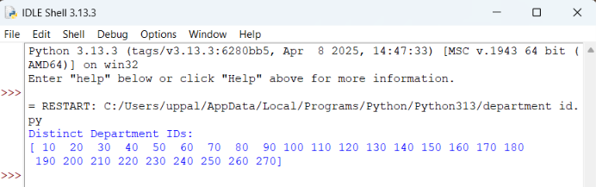

2.Display the IDs of Employees Who Have Done Two or More Jobs in the Past Using Pandas
Code:
import pandas as pd

# Create DataFrame
df = pd.DataFrame({
"EMPLOYEE_ID": [102,101,101,201,114,122,200,176,176,200],
"START_DATE": ["2001-01-13","1997-09-21","2001-10-28","2004-02-17","2006-03-24",
"2007-01-01","1995-09-17","2006-03-24","2007-01-01","2002-07-01"],
"END_DATE": ["2006-07-24","2001-10-27","2005-03-15","2007-12-19","2007-12-31",
"2007-12-31","2001-06-17","2006-12-31","2007-12-31","2006-12-31"],
"JOB_ID": ["IT_PROG","AC_ACCOUNT","AC_MGR","MK_REP","ST_CLERK",
"ST_CLERK","AD_ASST","SA_REP","SA_MAN","AC_ACCOUNT"],
"DEPARTMENT_ID": [60,110,110,20,50,50,90,80,80,90]
})
# Find employees with two or more jobs
result = df.groupby("EMPLOYEE_ID").filter(lambda x: len(x) >= 2)
# Display unique employee IDs
print("Employees who have done two or more jobs:")
print(result["EMPLOYEE_ID"].unique())

Output:
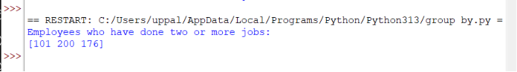

3.Display the Details of Jobs in Descending Order of Job Title Using Pandas
Code:
import pandas as pd
# Create DataFrame
df = pd.DataFrame({
"JOB_ID": ["AD_PRES","AD_VP","AD_ASST","FI_MGR","FI_ACCOUNT","AC_MGR","AC_ACCOUNT", "SA_MAN","SA_REP","PU_MAN","PU_CLERK","ST_MAN","ST_CLERK","SH_CLERK",
"IT_PROG","MK_MAN","MK_REP","HR_REP","PR_REP"],
"JOB_TITLE": ["President","Administration Vice President","Administration Assistant",
"Finance Manager","Accountant","Accounting Manager","Public Accountant",
"Sales Manager","Sales Representative","Purchasing Manager",
"Purchasing Clerk","Stock Manager","Stock Clerk","Shipping Clerk",
"Programmer","Marketing Manager","Marketing Representative",
"Human Resources Representative","Public Relations Representative"],
"MIN_SALARY": [20080,15000,3000,8200,4200,8200,4200,10000,6000,8000,2500,5500,2008,2500,4000,9000,4000,4000,4500],
"MAX_SALARY": [40000,30000,6000,16000,9000,16000,9000,20080,12008,15000,5500,8500,5000,5500,10000,15000,9000,9000,10500]
})
# Sort by JOB_TITLE in descending order
result = df.sort_values(by="JOB_TITLE", ascending=False)
# Display result
print(result)

Output:
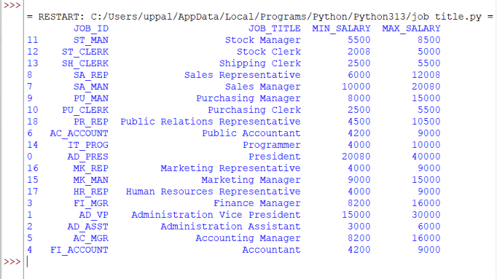

4.Create a Line Plot of Alphabet Inc. Stock Prices Between Two Dates
Python Code:
import pandas as pd
import matplotlib.pyplot as plt

# Load the dataset
df = pd.read_csv("Alphabet_Inc_Historical_Stock_Prices.csv")
# Convert Date column to datetime
df["Date"] = pd.to_datetime(df["Date"])
# Select dates (change these if needed)
start_date = "2023-01-03"
end_date = "2023-01-31"
filtered_df = df[(df["Date"] >= start_date) & (df["Date"] <= end_date)]
# Create line plot
plt.figure(figsize=(10,5))
plt.plot(filtered_df["Date"], filtered_df["Close"], marker="o")
plt.title("Historical Stock Prices of Alphabet Inc.")
plt.xlabel("Date")
plt.ylabel("Closing Price (USD)")
plt.xticks(rotation=45)
plt.grid(True)
plt.tight_layout()
plt.show()

Output:
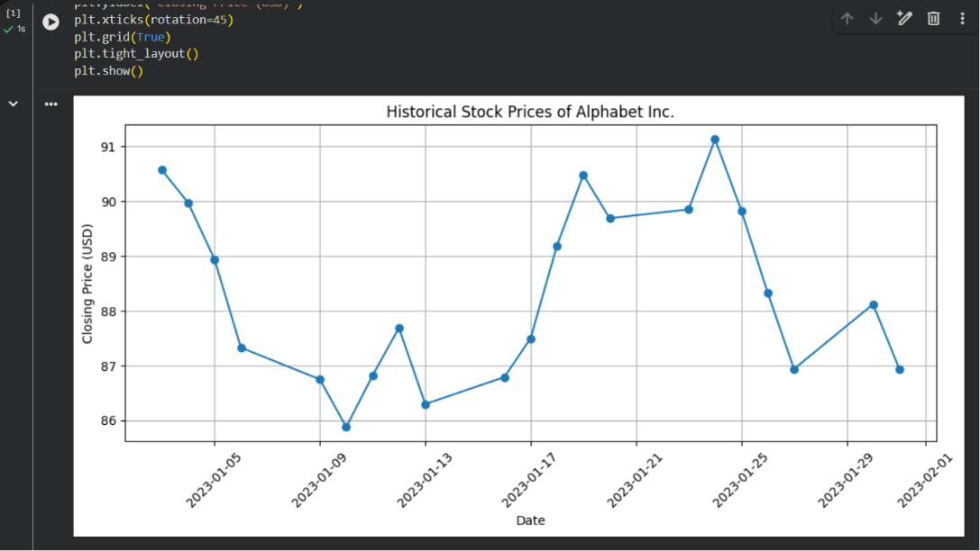

5. Write a Pandas program to create a bar plot of the trading volume of Alphabet Inc. stock between two specific dates.

Python Code:
import pandas as pd
import matplotlib.pyplot as plt
# Load the CSV file
df = pd.read_csv("Alphabet_Trading_Volume.csv")
# Convert Date column to datetime
df["Date"] = pd.to_datetime(df["Date"])
# Specify the date range
start_date = "2023-02-01"
end_date = "2023-02-28"
# Filter the data
filtered_df = df[(df["Date"] >= start_date) & (df["Date"] <= end_date)]
# Create bar plot
plt.figure(figsize=(10,5))
plt.bar(filtered_df["Date"].dt.strftime("%Y-%m-%d"), filtered_df["Volume"])
plt.title("Trading Volume of Alphabet Inc. Stock")
plt.xlabel("Date")
plt.ylabel("Trading Volume")
plt.xticks(rotation=45)
plt.tight_layout()
plt.show()
Output:
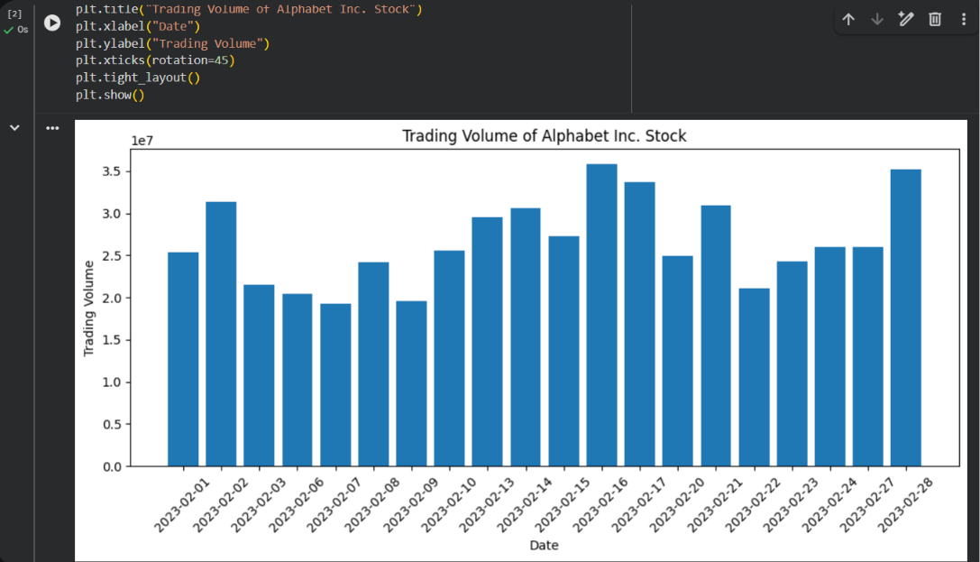

6 . A scatter plot of the trading volume of Alphabet Inc. stock between two specific dates.
Python Code:
import pandas as pd
import matplotlib.pyplot as plt
# Load the dataset
df = pd.read_csv("Alphabet_Inc_Trading_Volume_Dataset.csv")
# Convert Date column to datetime format
df["Date"] = pd.to_datetime(df["Date"])
# Select data between two specific dates
start_date = "2023-02-01"
end_date = "2023-02-28"
filtered_df = df[(df["Date"] >= start_date) & (df["Date"] <= end_date)]
# Create Scatter Plot
plt.figure(figsize=(12,6))
plt.scatter(filtered_df["Date"], filtered_df["Volume"])
plt.title("Trading Volume of Alphabet Inc. Stock")
plt.xlabel("Date")
plt.ylabel("Trading Volume")
plt.xticks(rotation=45)
plt.grid(True)
plt.tight_layout()
plt.show()

Output:
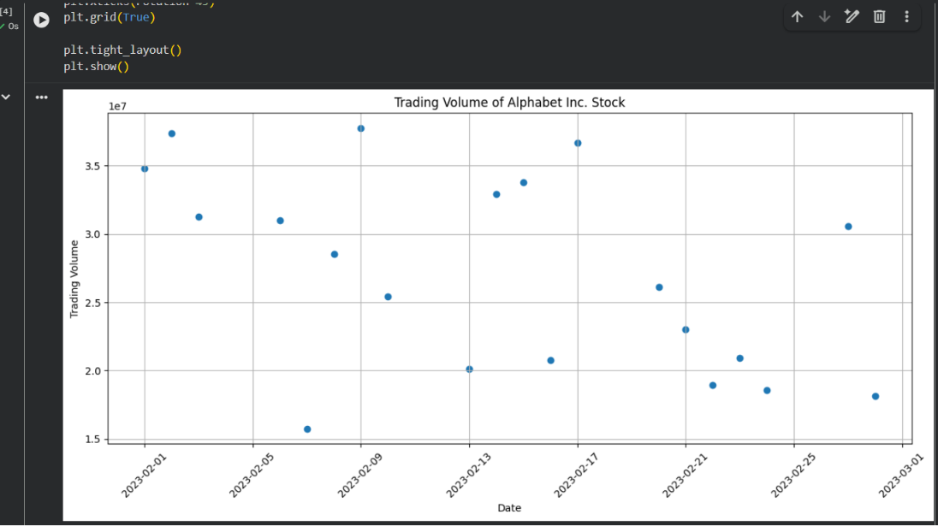
7. Create a Pivot table and find the maximum and minimum sale value of the items.(refer sales_data table)
Python Code:
import pandas as pd
# Load the dataset
df = pd.read_csv("sales_data.csv")
# Create Pivot Table
pivot = pd.pivot_table(
df,
values="Sale_Value",
index="Item",
aggfunc=["max", "min"]
)
print(pivot)

Output:
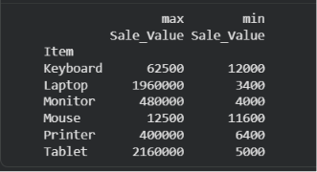

8. Create a Pivot table and find the item wise unit sold. .(refer sales_data table)
Python Code:
import pandas as pd
# Load the dataset
df = pd.read_csv("sales_data.csv")
# Create Pivot Table
pivot = pd.pivot_table(
df,
values="Units_Sold",
index="Item",
aggfunc="sum"
)
print(pivot)

Output:
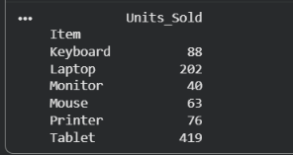

9.Find the total sale amount region-wise, manager-wise, and salesman-wise. (Refer Sales_data table)
Python Code:
import pandas as pd
# Load the dataset
df = pd.read_csv("Sales_data.csv")
# Create Pivot Table
pivot = pd.pivot_table(
df,
values="Sale_amt",
index=["Region", "Manager", "SalesMan"],
aggfunc="sum"
)
print(pivot)

Output:
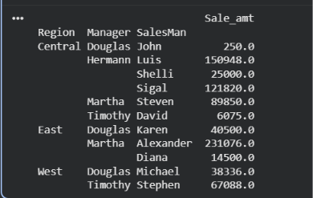

10.To highlight the negative numbers in red and positive numbers in black.
Python Code:
import pandas as pd
import numpy as np
# Create a DataFrame with random values
np.random.seed(10)
df = pd.DataFrame(
np.random.randn(10, 5),
columns=['A', 'B', 'C', 'D', 'E']
)
# Function to highlight values
def highlight_numbers(value):
if value < 0:
return 'color: red'
else:
return 'color: black'
# Display the styled DataFrame
styled_df = df.style.map(highlight_numbers)
styled_df

Output:
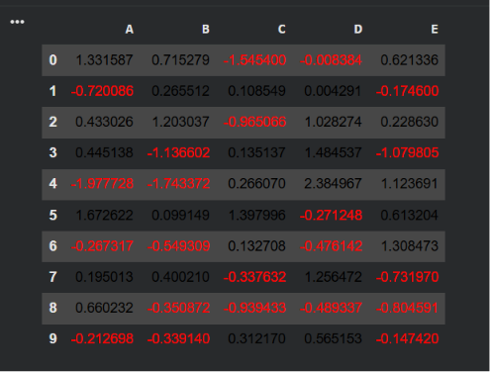

11.Highlight NaN Values in a DataFrame
Python Code:
import pandas as pd
import numpy as np
# Create a DataFrame with random values
np.random.seed(10)
df = pd.DataFrame(
np.random.randn(10, 4),
columns=['A', 'B', 'C', 'D']
)
# Convert some values to NaN
df.iloc[1, 2] = np.nan
df.iloc[4, 0] = np.nan
df.iloc[7, 3] = np.nan
# Function to highlight NaN values
def highlight_nan(value):
if pd.isna(value):
return 'background-color: yellow'
return ''
# Display the styled DataFrame
styled_df = df.style.map(highlight_nan)
styled_df

Output:
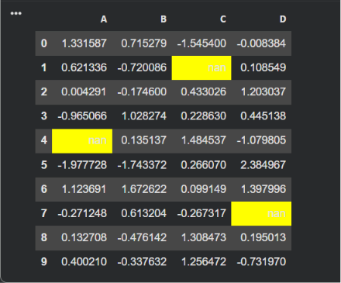

12.Set DataFrame Background Black and Font Color Yellow

Python Code:
import pandas as pd
import numpy as np
# Create a DataFrame with random values
np.random.seed(10)
df = pd.DataFrame(
np.random.randn(10, 4),
columns=['A', 'B', 'C', 'D']
)
# Apply background color and font color
styled_df = df.style.set_properties(**{
'background-color': 'black',
'color': 'yellow'
})
# Display the styled DataFrame
styled_df

Output:
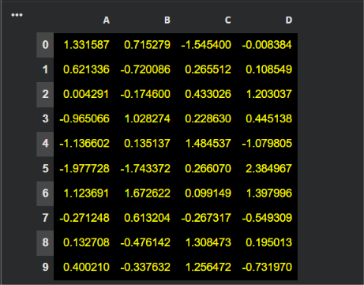

13.Detect Missing Values in a DataFrame
Python Code:
import pandas as pd
import numpy as np
# Create a DataFrame
df = pd.DataFrame({
'ord_no': [70001, np.nan, 70002, 70004, np.nan],
'purch_amt': [150.50, 270.65, 65.26, 110.50, 948.50],
'ord_date': ['2012-10-05', '2012-09-10', np.nan, '2012-08-17', '2012-09-10'],
'customer_id': [3002, 3001, 3001, 3003, 3002],
'salesman_id': [5002, 5003, 5001, np.nan, 5002]
})
# Detect missing values
print(df.isnull())

Output:
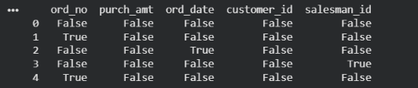

14.Find and Replace Missing Values in a DataFrame
Python Code:
import pandas as pd
import numpy as np
# Create a DataFrame
df = pd.DataFrame({
'ord_no': [70001, np.nan, 70002, 70004, np.nan],
'purch_amt': [150.50, 270.65, np.nan, 110.50, 948.50],
'ord_date': ['2012-10-05', '2012-09-10', np.nan, '2012-08-17', '2012-09-10'],
'customer_id': [3002, 3001, 3001, np.nan, 3002],
'salesman_id': [5002, 5003, 5001, np.nan, 5002]
})
# Replace missing values
df = df.fillna("Not Available")
# Display the DataFrame
print(df)

Output:
